**Table of Contents**



**FPT International School**

--- o0o ---

**PROJECT REPORT**

**HTML5 – TRIM GYM**

**Course / Module :** Project S1

Batch: **T1804E**

Semester: 1

Group:

1. Nguyen Thanh Tung - D00762
2. Hoang Van Quynh - D00730
3. Duong Tuan Linh - D00772

Faculty: Bui Thi Oanh

**Hanoi - 10/2018**

1. Problem Definition 3

i. Introduction 3

ii. Implementation Environment 4

User Stories 5

User type (Example: Customer) 5

Story 1 : View 5

Besides, customers can: 5

- Learn the exercises to increase the muscles of the chest, muscles,… 5

Story 2: Feedback , try register 5

- Customers can report, feedback on the quality of service, the quality of training conditions and all related 5

2. View model 5

5

3. UI\UX 6

3.1 UI 1 - HOME 6

3.2 UI 2 – ABOUT US 8

3.3 UI 3 – CLUB 10

3.4 UI 4 - TRAINER 13

3.5 UI 5 – SCHEDULE 15

3.6 UI 6 – LIBRARY 17

3.7 UX 7 – CONTACT US 24

3.8 UX 8 – TRY REGISTER 25

3.9 UX 9 – FEEDBACK 27

3.10 UI 10 – RECRUITMENT 29

3.11 UI 11 – HOW TO USE 31

3.12 UI 12 – PRIVACY POLICY 32

4. Summary 33

# Problem Definition

### Introduction

In 1983, TRIM-GIM became the first and largest international fitness company in America. With the mission of "Make Life Better", TRIM-GYM is not just like normal gym. This is the heart of dynamic lifestyle, to inspire, bring joyful fun as well as new vitality for the community.

This is where convergence of exercise, fashion and entertainment in a healthy environment, full of energy. From music and light to modern equipment and world-class coaches, every detail is meticulously prepared to provide a positive and positive experience. Best for customers. The success of TRIM-GYM is linked to the vision and leadership of its founder and CEO, Randy G. Dobson. Randy has blown his passionate company of life and entertainment, which has revolutionized the way fitness is practiced throughout Europe.

The members of TRIM-GYM's senior management team have been extremely important to the development of some of the top fitness brands, such as 24 Hour Fitness, California Fitness, Jackie Chan Sport, UFC Gyms, Crunch Fitness, and Les Mills.

With a combined board of over 30 years of experience in dozens of different countries, TRIM-GYM has owned and is one of the most experienced and professional leaders in the fitness industry. This is also the main reason TRIM-GYM is loyal and consistent in implementing the brand's commitment to make life better.

Trim-Gym is 35 years old fitness centre. Fitness fads come and go, and we have learned what is classic and has longevity: a commitment to serving others. We have decided to come up with our website. It will provide all information about us to our clients and fitness freak people.

A website needs to be designed to details of various locations of our fitness centres, types of services we offer and various instruments available with us.

The website is to be developed for the Windows Platform using HTML5, JavaScript and Geolocation. The site should work well in all leading browsers including Chrome, IE, Firefox etc.

**Requirement Specification:**

TRIM-Gym site is to be created based on the following requirements.

1. The Home Page should be created with a suitable logo, the header section can be added which will show various fitness images.
2. The site must contain the links to navigate through various fitness therapy.
3. Site should have different section for Men and Women and display fitness programs accordingly.
4. Various exercises must be categorized like (Cardio, Muscle, ABS, Arms etc.)
5. Details and Guidelines should be provided for each type of workout/exercise.
6. Website should provide section for various Nutrition plans offered in the Gym.
7. Training Cost should be provided for various plans offered.
8. Website should provide list of all branches with proper address and location map.
9. Gallery section should be added for viewing different images.
10. Feedback must be allowed to enter by the viewer
11. Site map, Gallery, about us, Queries link.
12. There should be a “Contact Us” page which will have the Address of the Company which should be displayed using GeoLocation API (eg. GoogleMaps) and the email address which when clicked will invoke the local mail client from where they can send an email.
13. The complete description must be allowed to get download as pdf or doc file.
14. The advertise section with various facilities provided should be mentioned.

### Implementation Environment

* HTML5
* CSS
* BOOTSTRAP
* JS
* JQUERY
* ANGULARJS
* NODEJS
* PHOTOSHOP

# User Stories

## User type (Example: Customer)

### Story 1 : View

Users can search:

* Tranner infomation
* Course information
* The nearest club

### Besides, customers can:

### Learn the exercises to increase the muscles of the chest, muscles,…

* Route set
* Nutrition to have a perfect body

### Story 2: Feedback , try register

### Customers can report, feedback on the quality of service, the quality of training conditions and all related

* Customers can try register to free training 1 day.

# 

# View model

Home

Curent Events

Contact Us

Trainer

Library

Schedule

Club

About Us

## 

Information about the coaches

Send information

for advice

About the Trym Gym, the history of formation

Information on existing offices

Schedule

information for member

Experience about: cardio, muscle, nutrition and galery

Try Register

Client can send information

for advice to quickly register

# UI\UX

## UI 1 - HOME

Example 1: Home

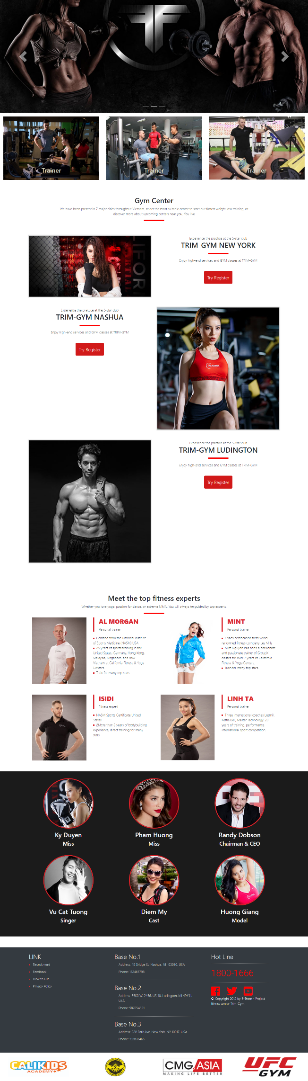



## UI 2 – ABOUT US

Example 1: ABOUT US

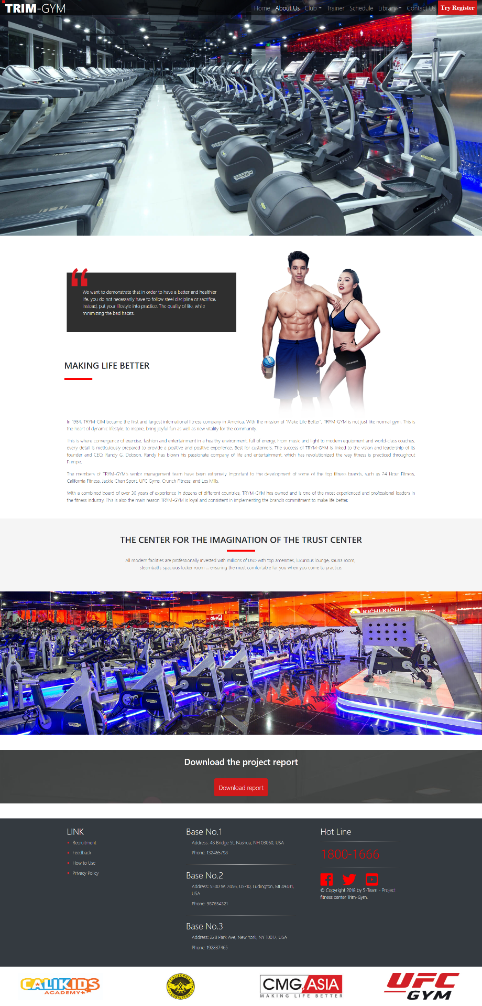

Example 2: Download Report to know all about this website. If you want, you can download it.

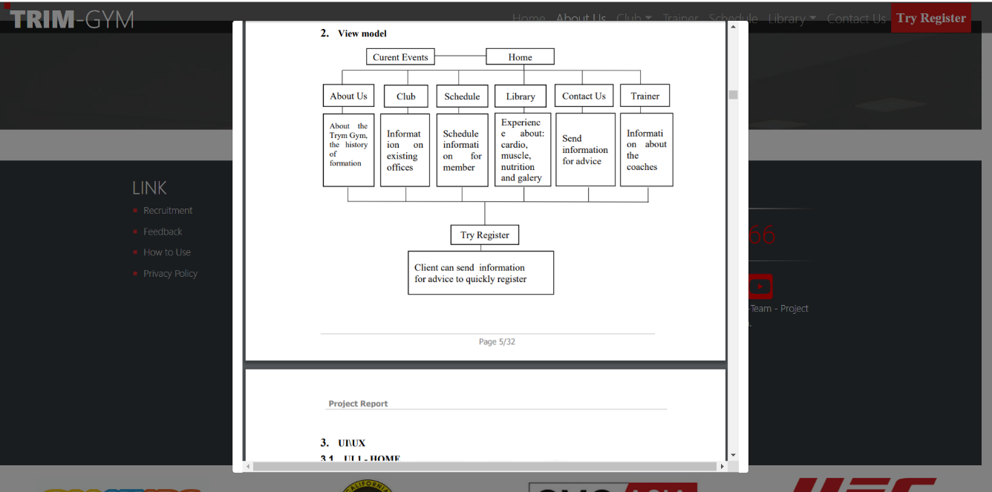

## UI 3 – CLUB

Example 1 : NASHUA

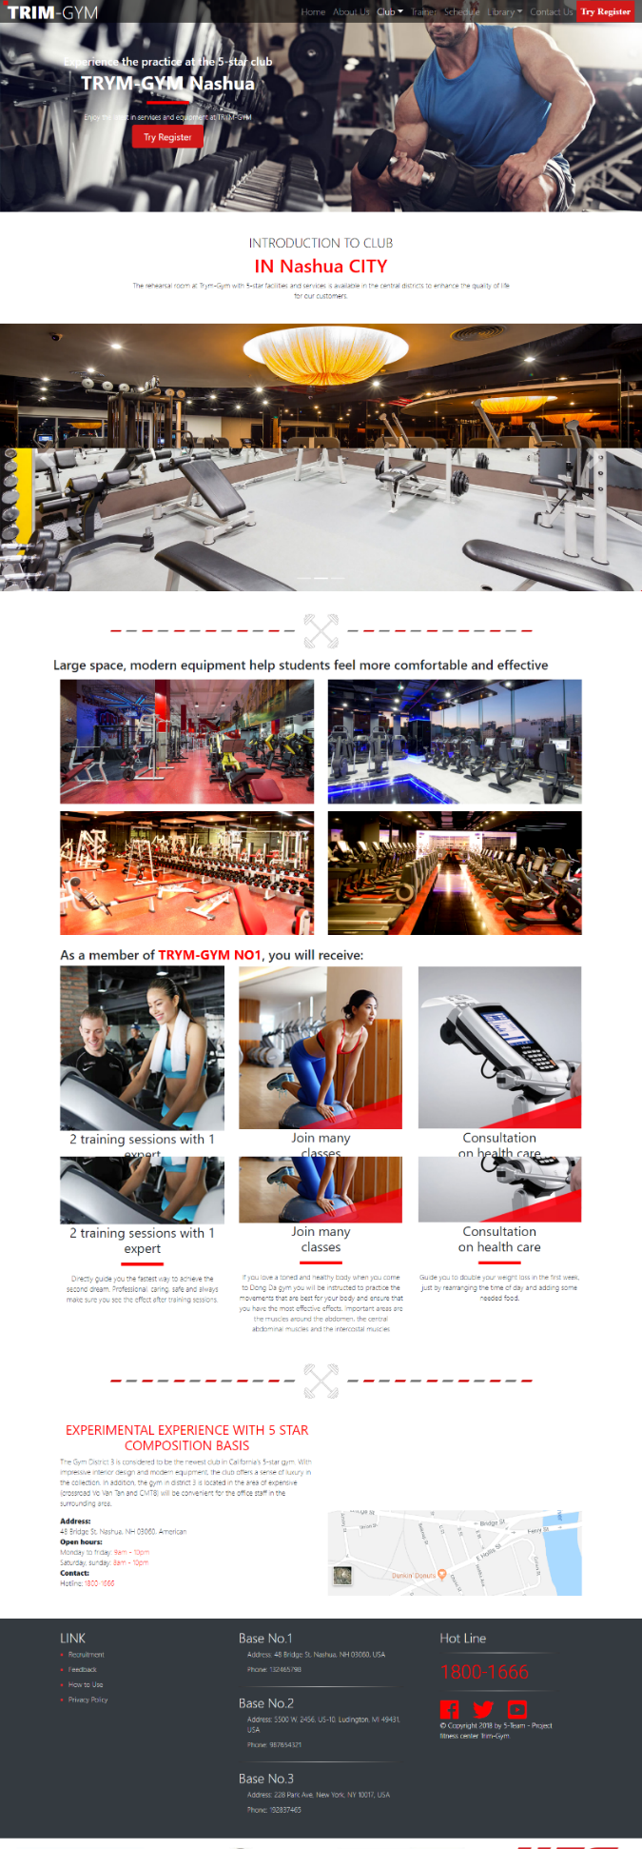

Example 2 : LUDINGTON

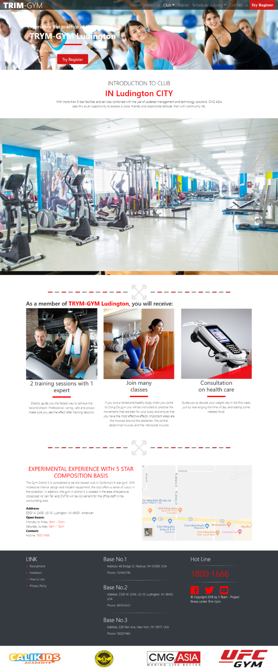

Example 3 : NEW YORK

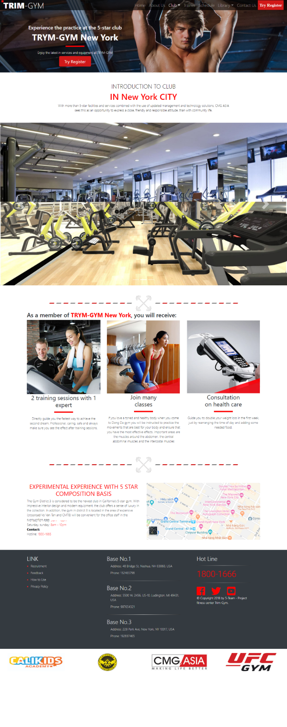

## UI 4 - TRAINER

Example 1: TRAINER

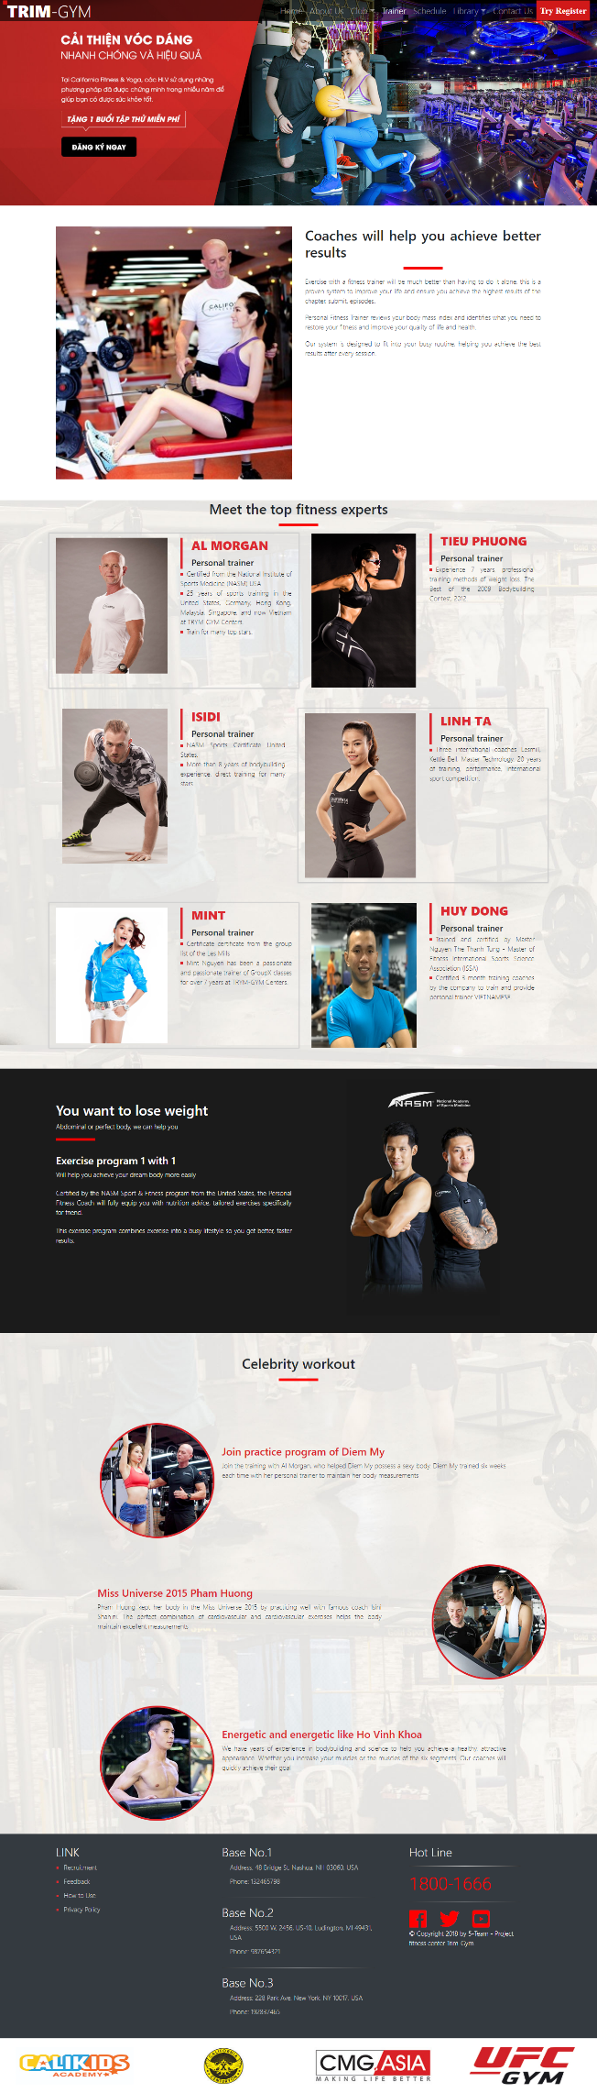



## UI 5 – SCHEDULE

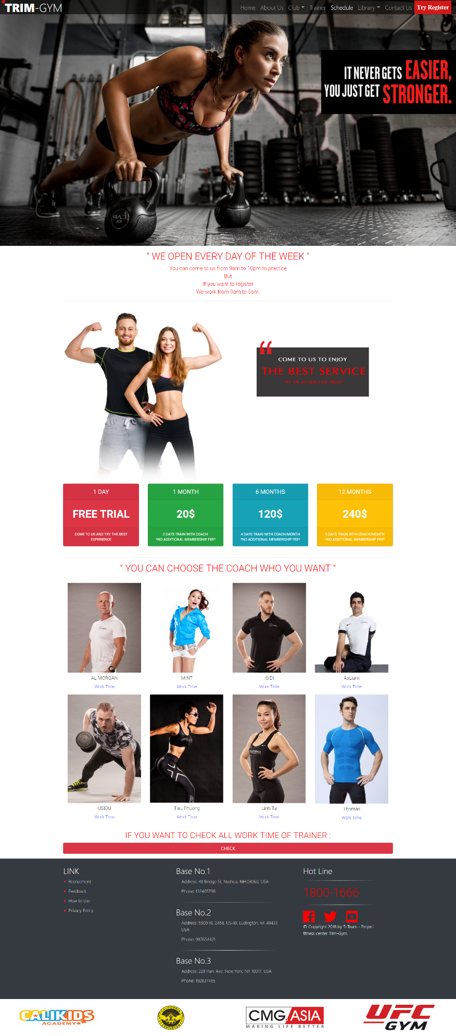

Example 1: Click to Work time to see trainer’s schedule.

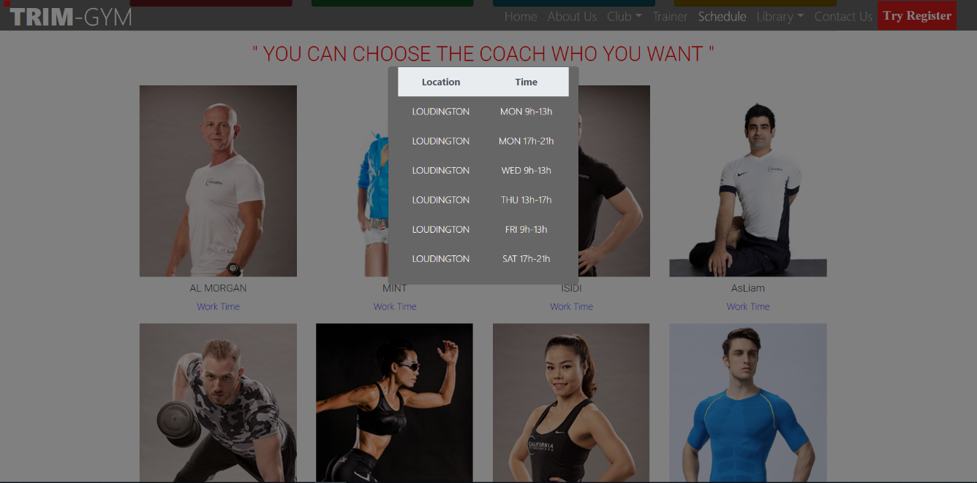

Example 2: Click to Check to see all trainer’s schedule.

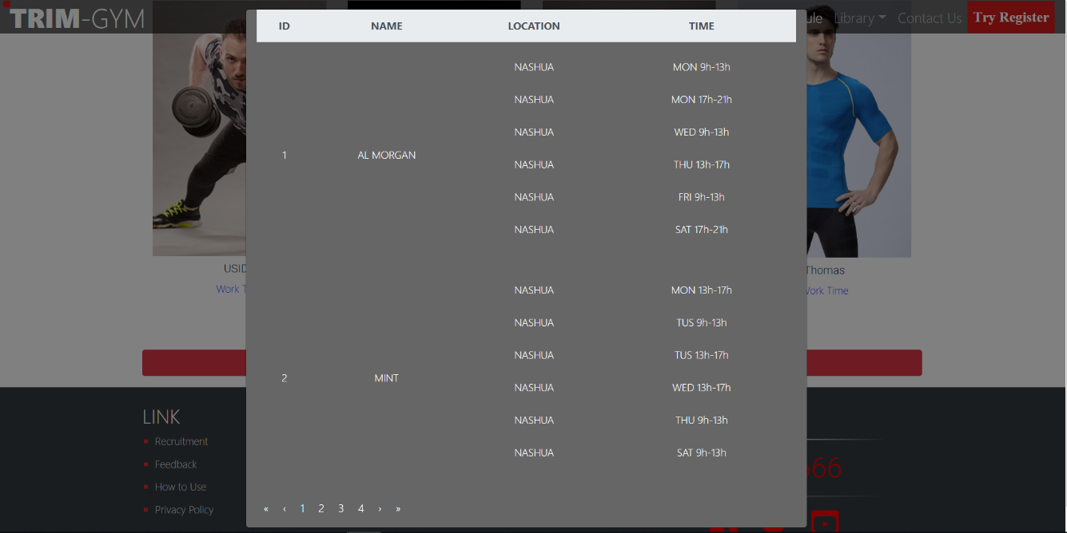

## UI 6 – LIBRARY

Example 1: CARDIO

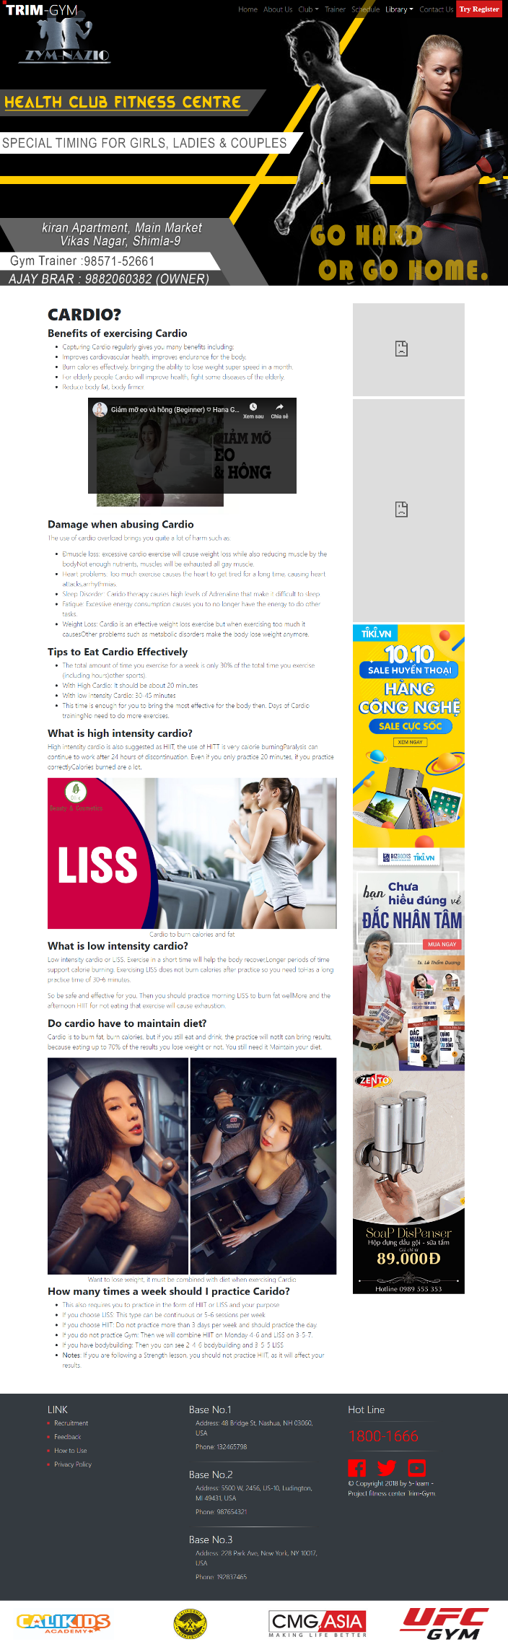



Example 2: MUSCLE

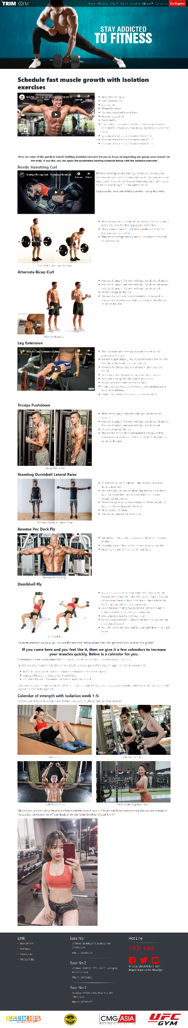



Example 3: NUTRITION

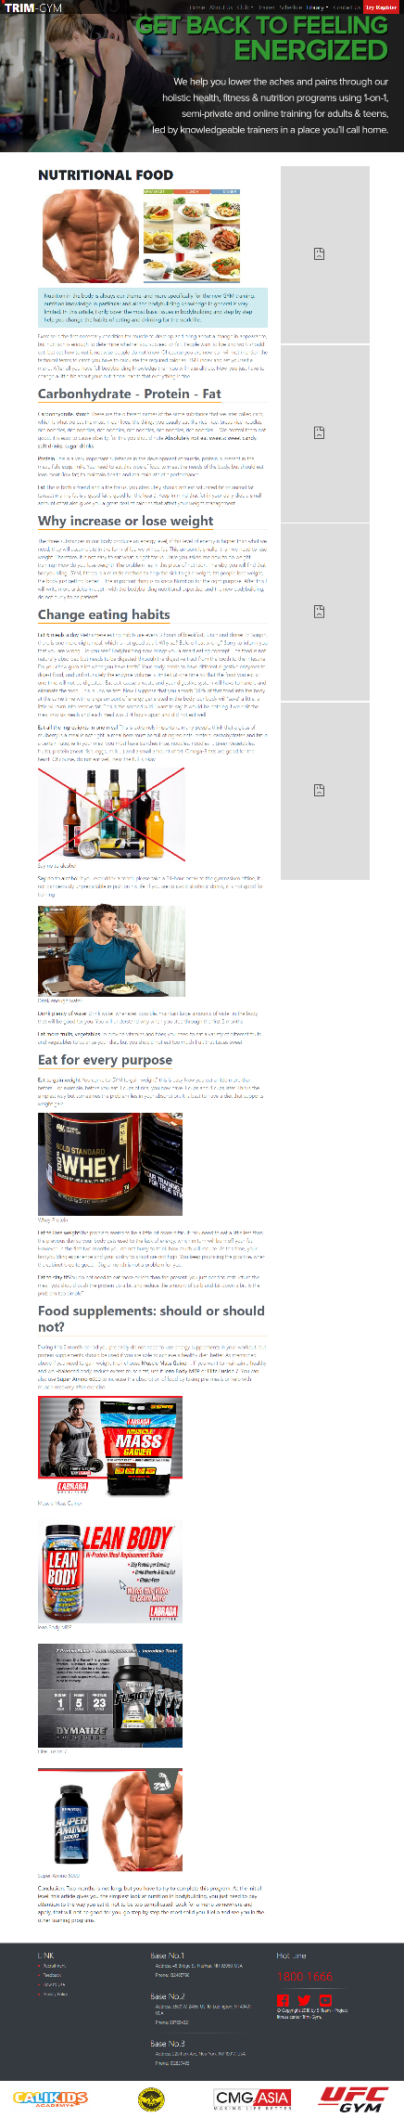



Example 4: GALLERY

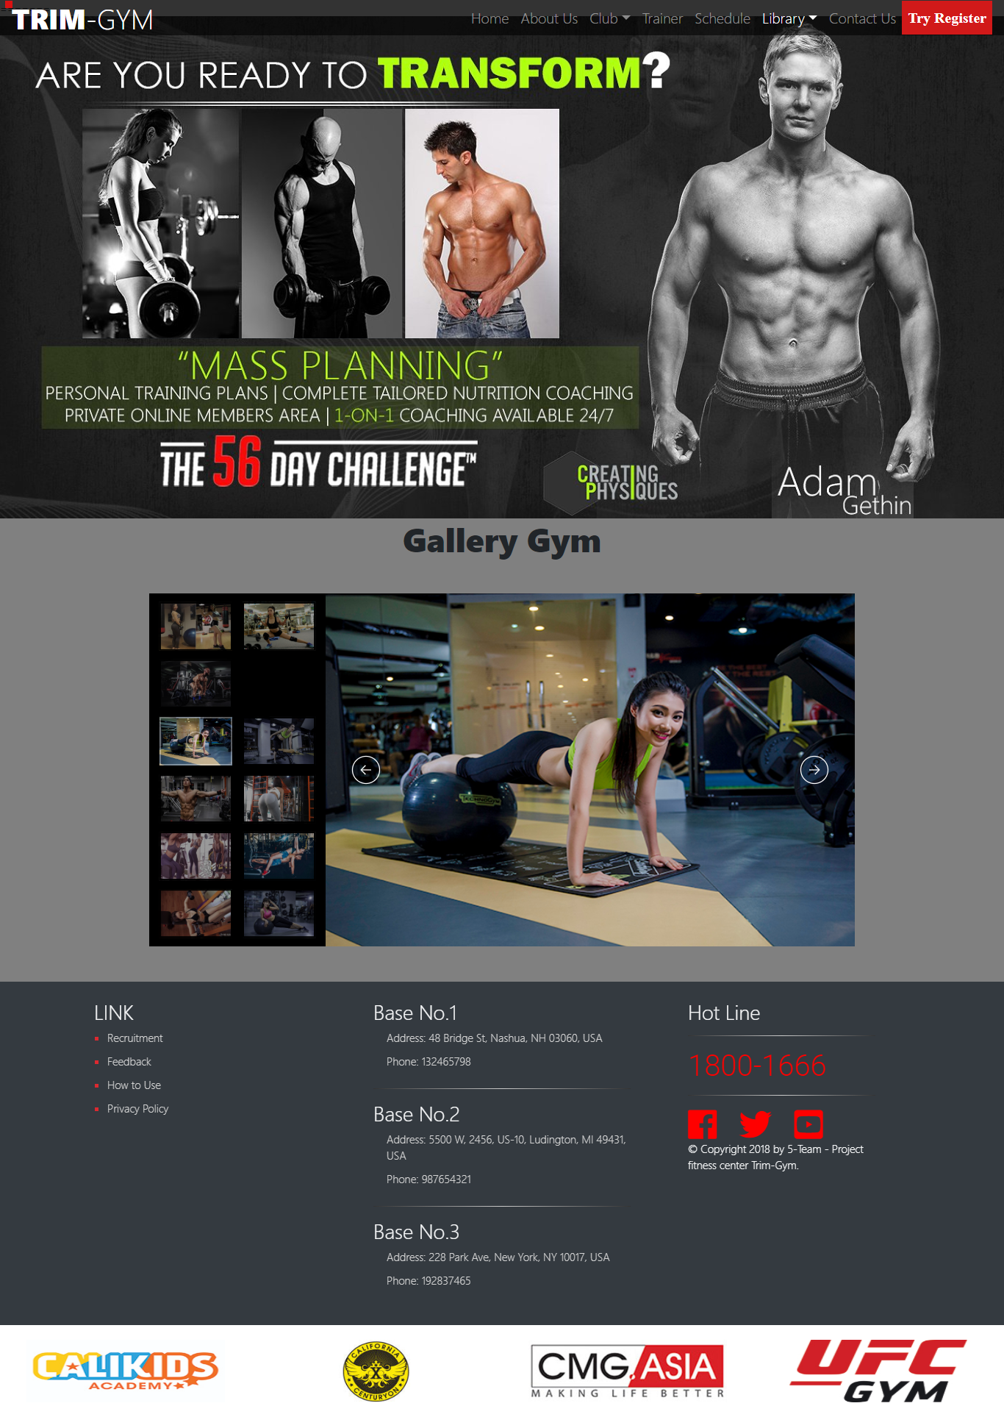

## UX 7 – CONTACT US

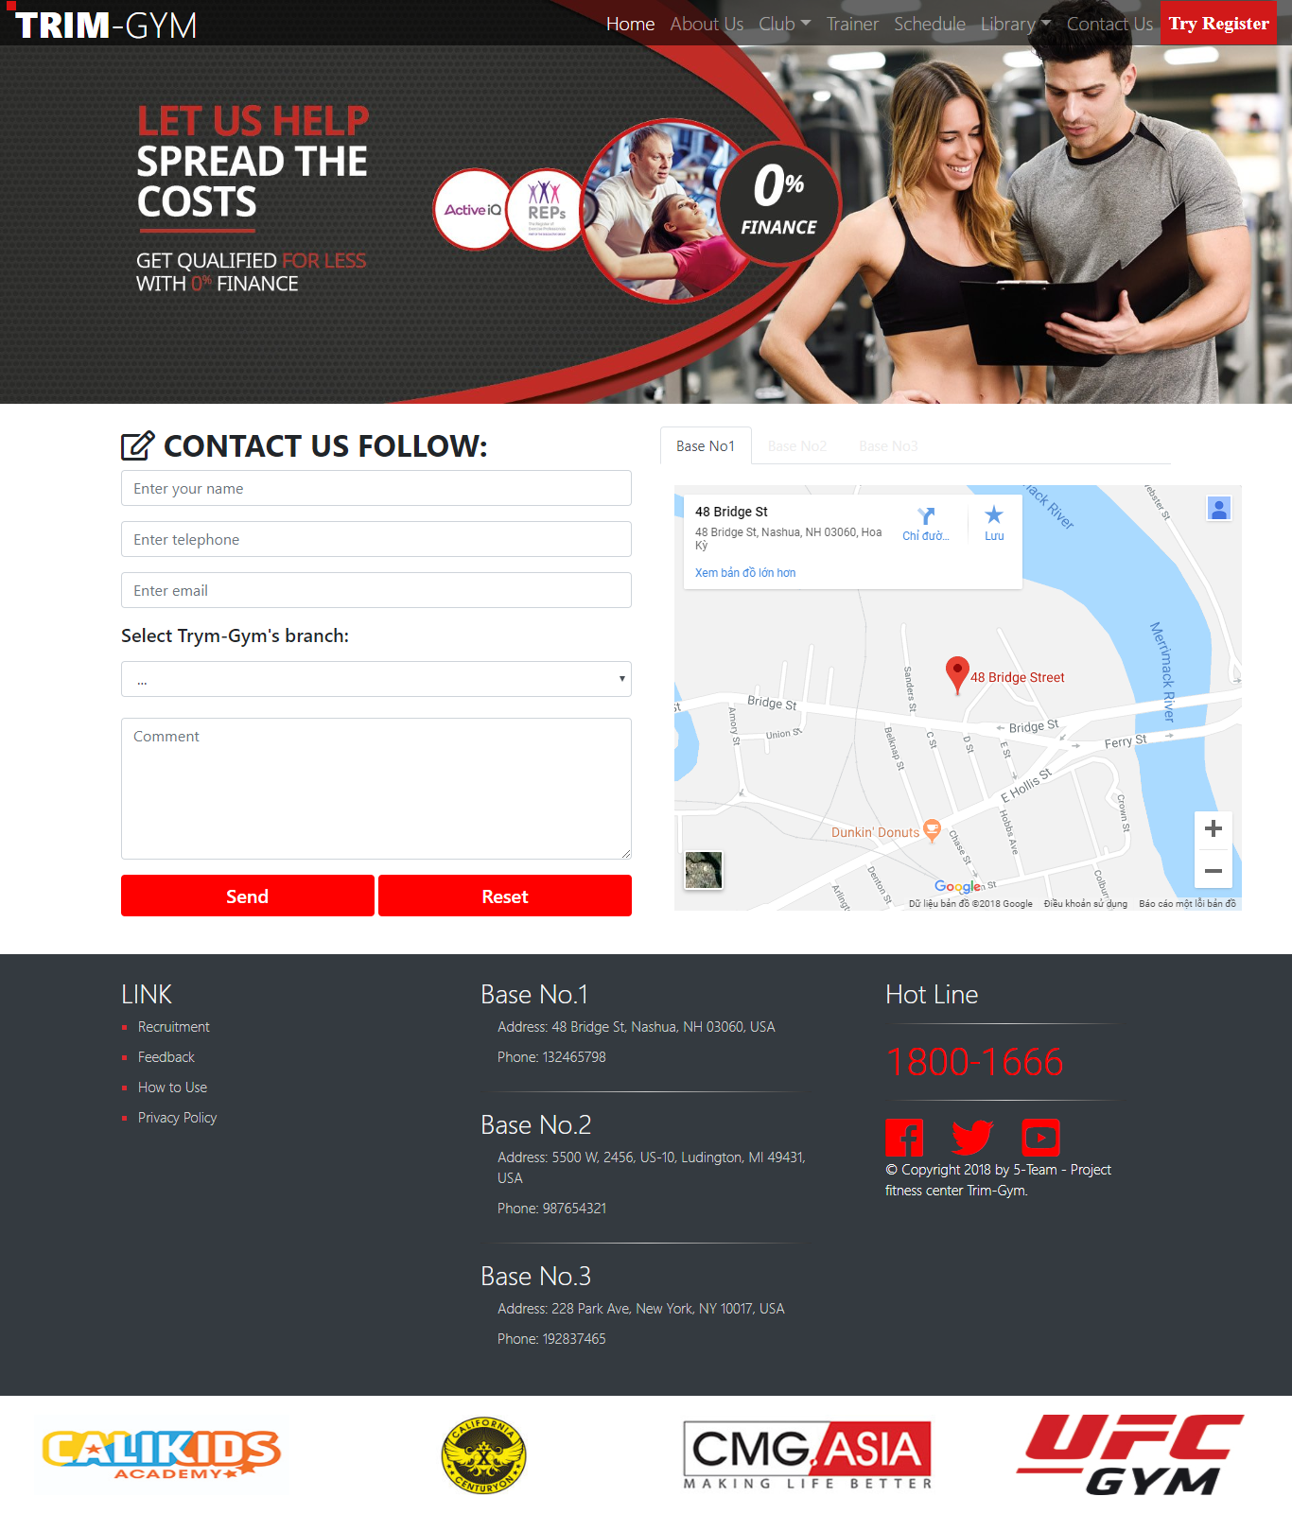

## UX 8 – TRY REGISTER

Example 1: Pop-up Form to Validate

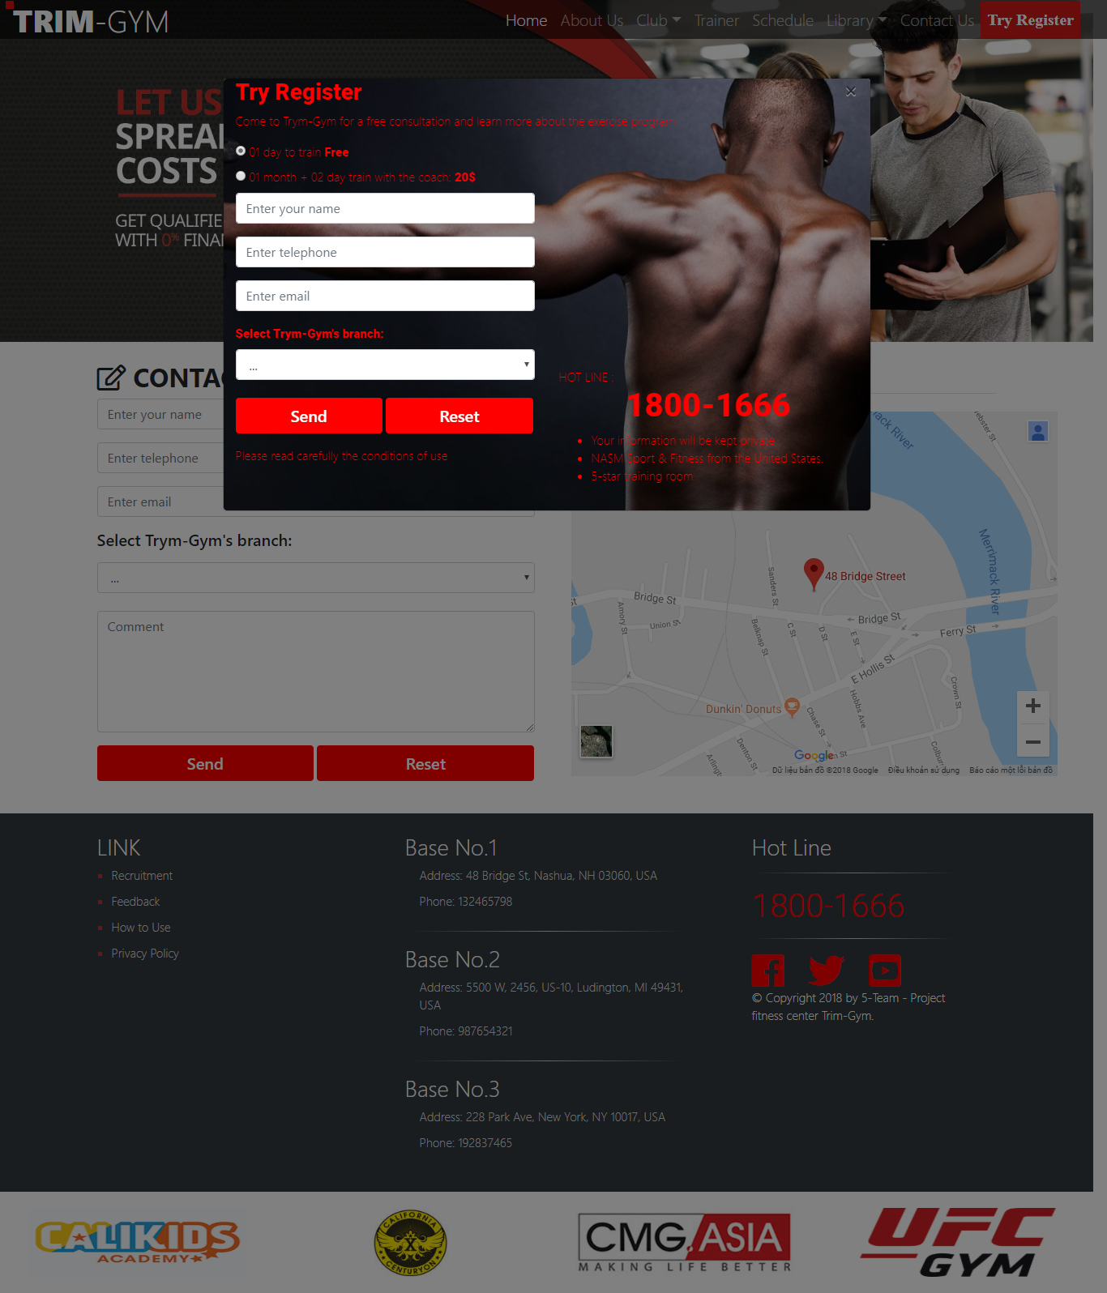

Example 2: After Submit success

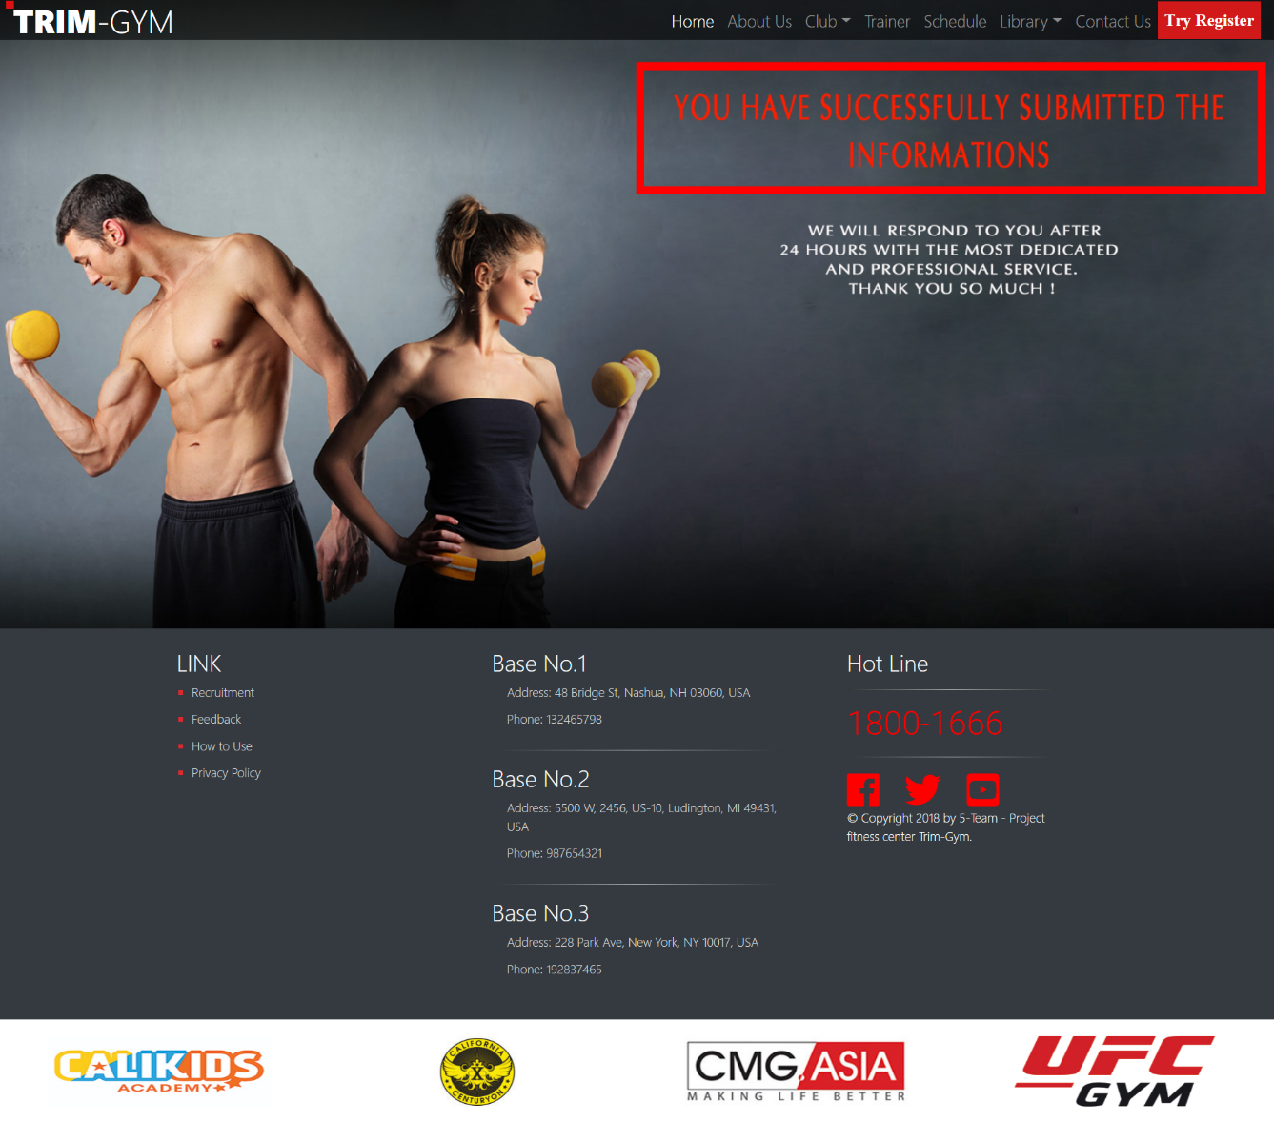

## UX 9 – FEEDBACK

Example 1: Form to Validate

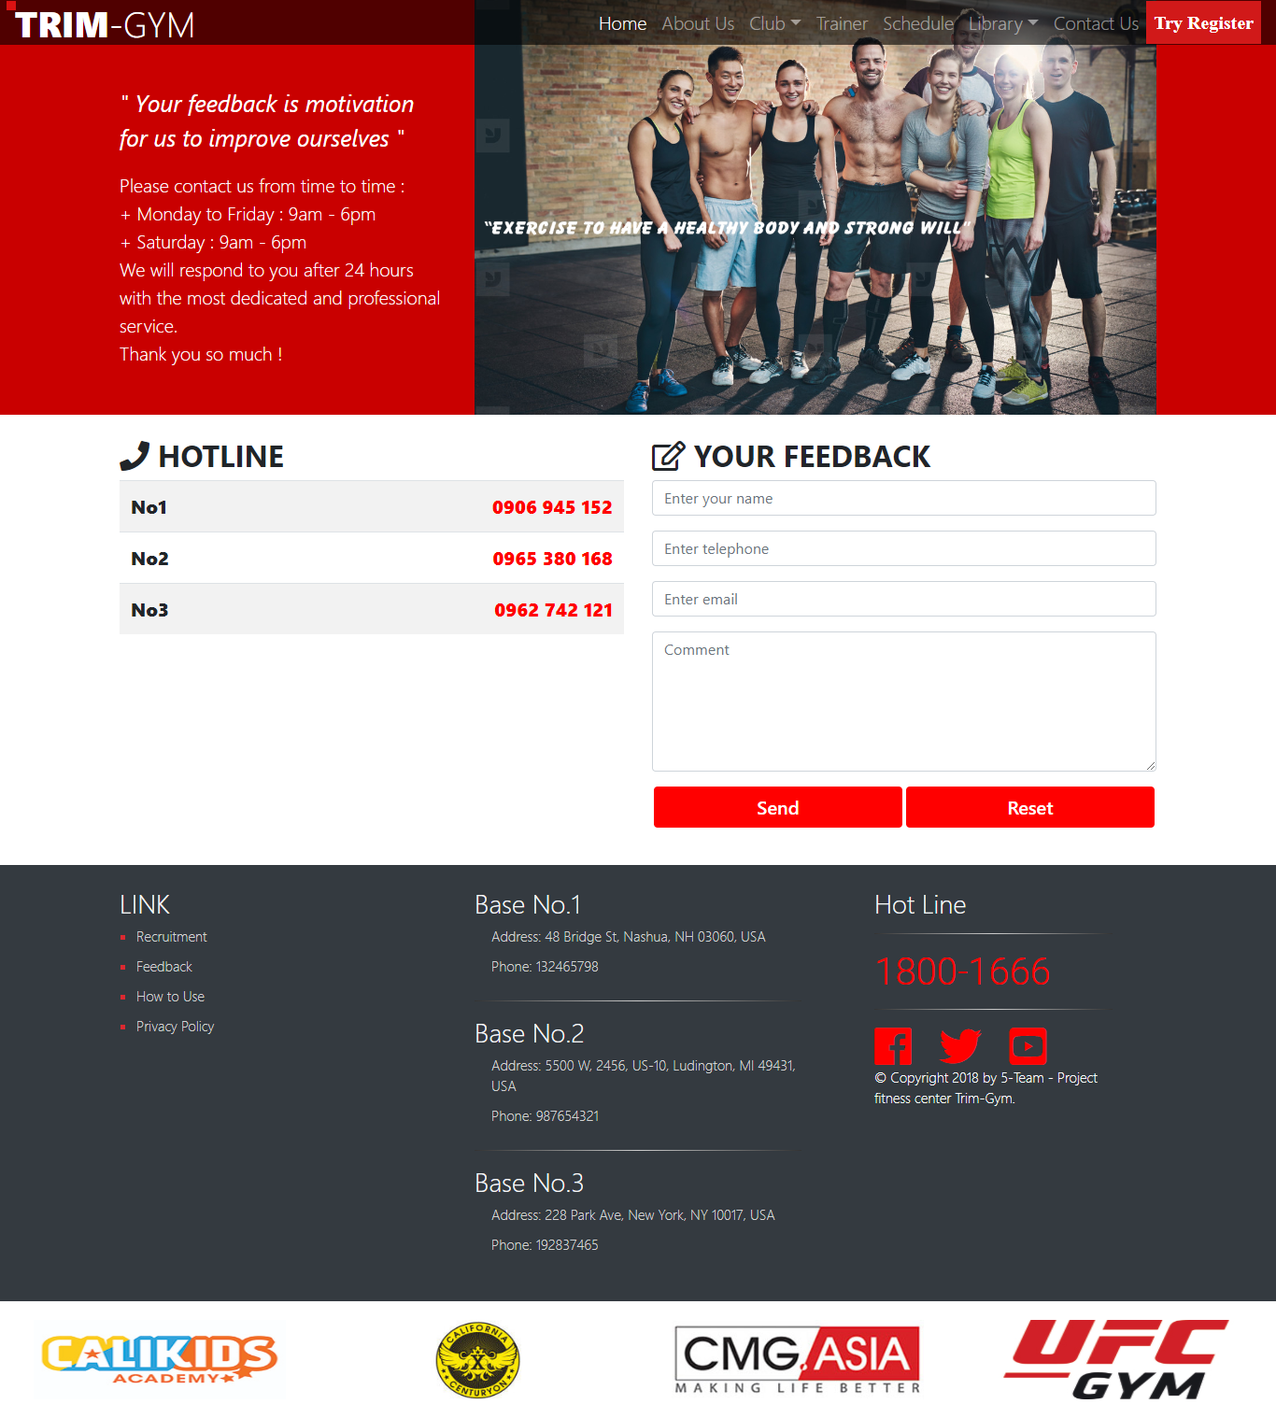

Example 2: After Submit success



## UI 10 – RECRUITMENT

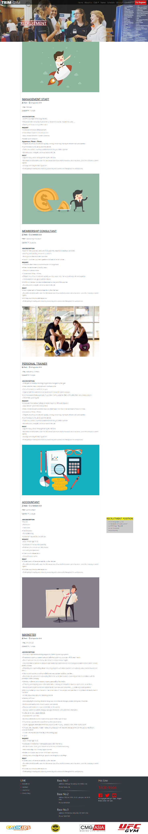

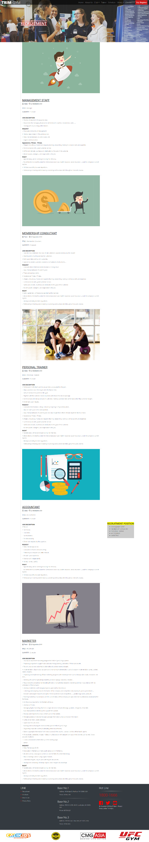

## UI 11 – HOW TO USE

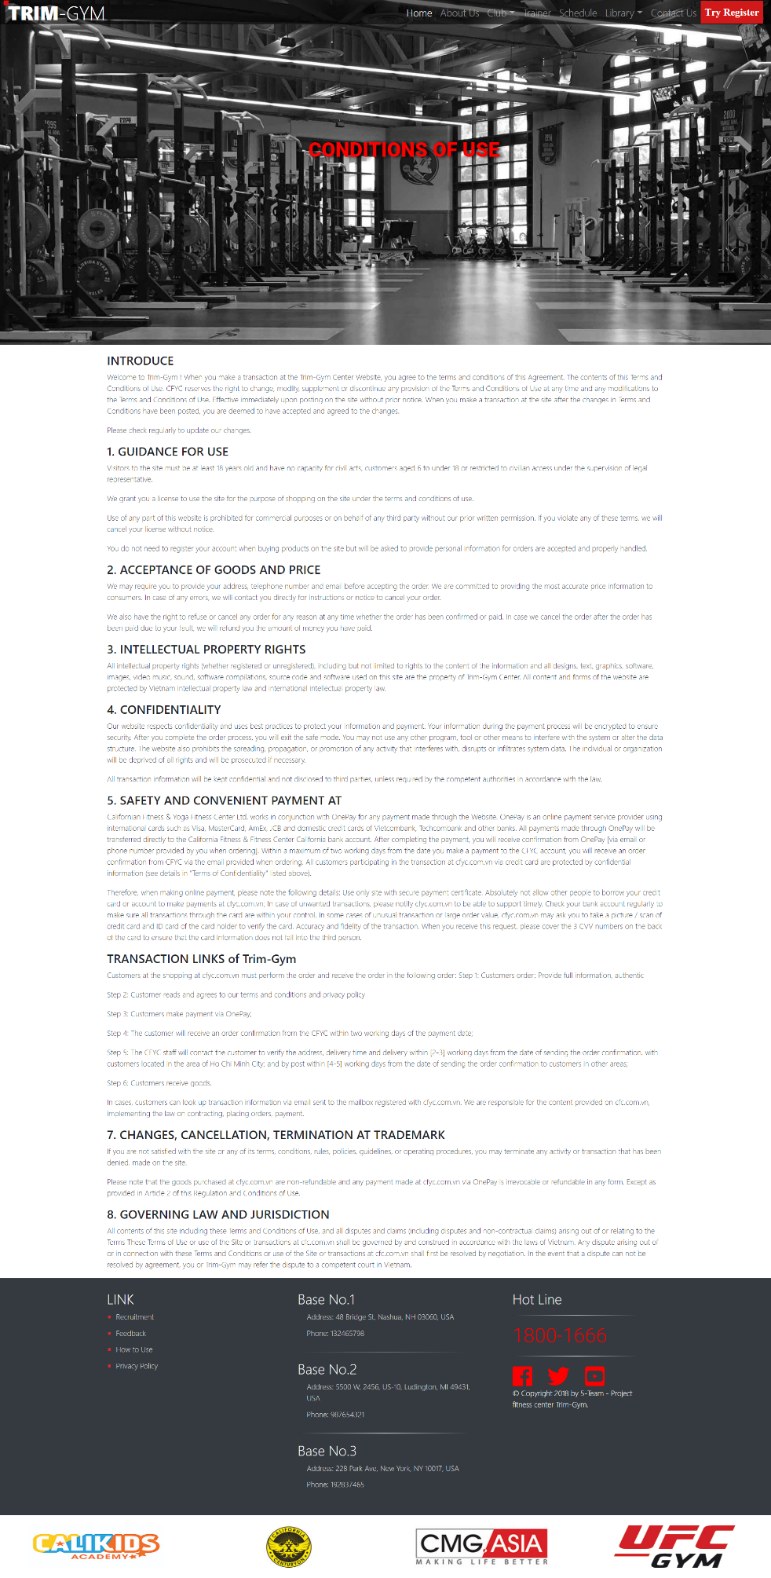

## UI 12 – PRIVACY POLICY

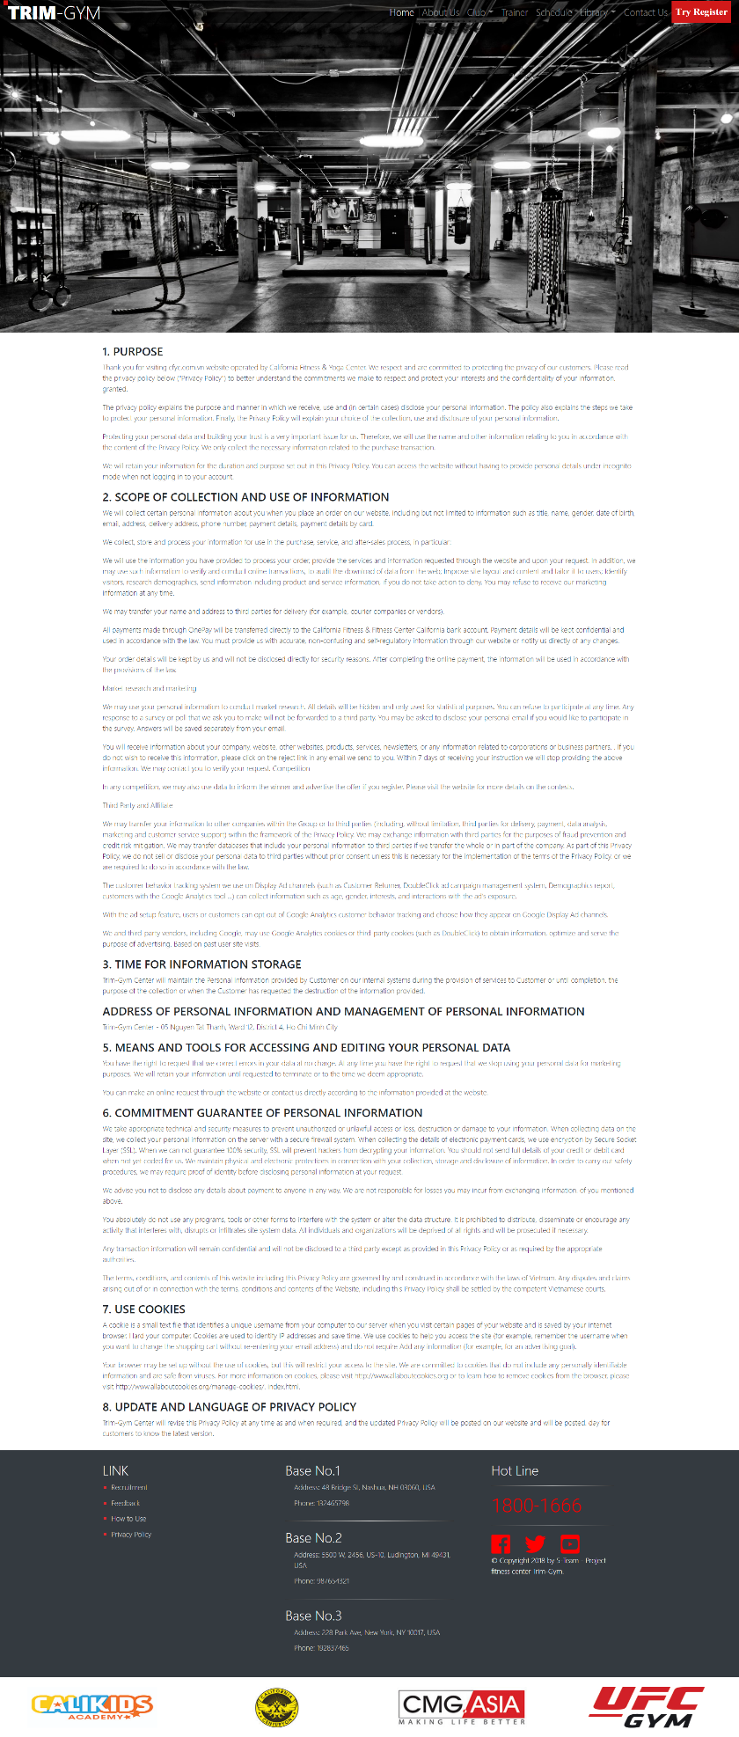

# Summary

With the requirements of the project, the team needs to build a website with many pages that containing the necessary information, including 16 pages and assignment to project team members responsible for each page as bellow:

|  |  |  |  |
| --- | --- | --- | --- |
| **ID** | **Item** | **Details (Wiki)** | **Responsible** |
| 1 | Navigation bar and Footer | About the links of the pages of the website. Introduce the address and phones of the center, other publics. | Nguyen Thanh Tung |
| 2 | Home Page | About the services of the center of the famous coaches and students | Hoang Van Quynh |
| 3 | About Us Page | Introduce the history of the center | Hoang Van Quynh |
| 4 | Clubs Page | Introduce the headquarters of the center | Hoang Van Quynh |
| 5 | Trainer Page | Introduce famous trainers and celebrities who have practiced here | Hoang Van Quynh |
| 6 | Schedule Page | Introduce training schedule  (back end about trainer’s worktime) | Nguyen Thanh Tung |
| 7 | Library Page | Introduce Cardio, Muscle, Nutrition and Gallery of TRIM-Gym | Duong Tuan Linh |
| 8 | Contact Us Page | Customers send information for consultation | Duong Tuan Linh |
| 9 | Try Register  Pop-up | Customers register trial | Nguyen Thanh Tung |
| 10 | Recruitment Page | Recruit relevant positions | Nguyen Thanh Tung |
| 11 | Feedback Page | Customer messages | Nguyen Thanh Tung |
| 12 | Privacy Policy Page | Respect and are committed to protecting the privacy of our customers | Nguyen Thanh Tung |
| 13 | How to use Page | Conditions of use | Nguyen Thanh Tung |